**Lecture 79,80: Client Side Load Balancing with Ribbon**

With previous approach , only CurrencyConversionService could only talk to any one instance of CurrencyExchangeService. With Ribbon implementation , we’ll try to talk to any instance of CES.

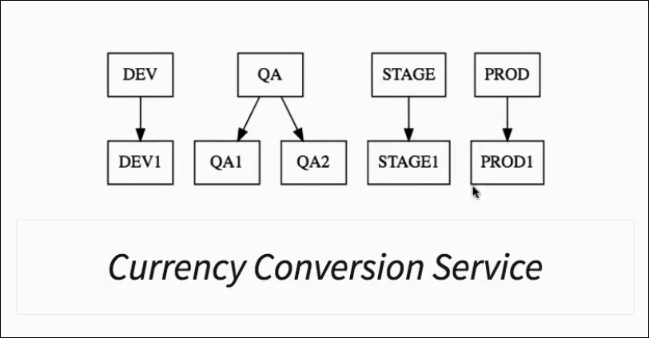

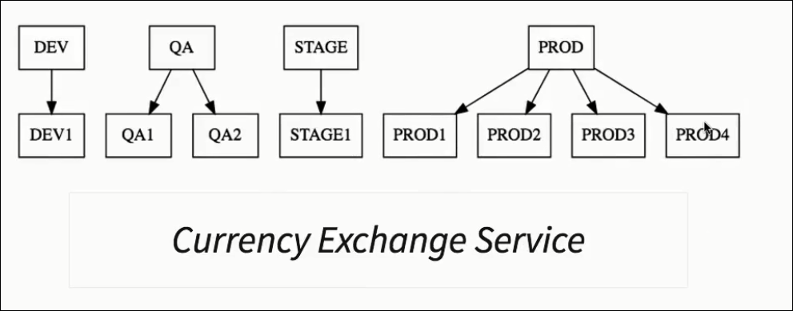

**This is where Ribbon comes into picture :**

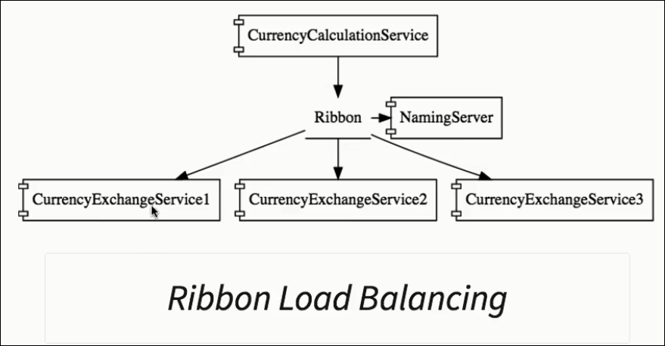

**Step1: Add pom dependency**

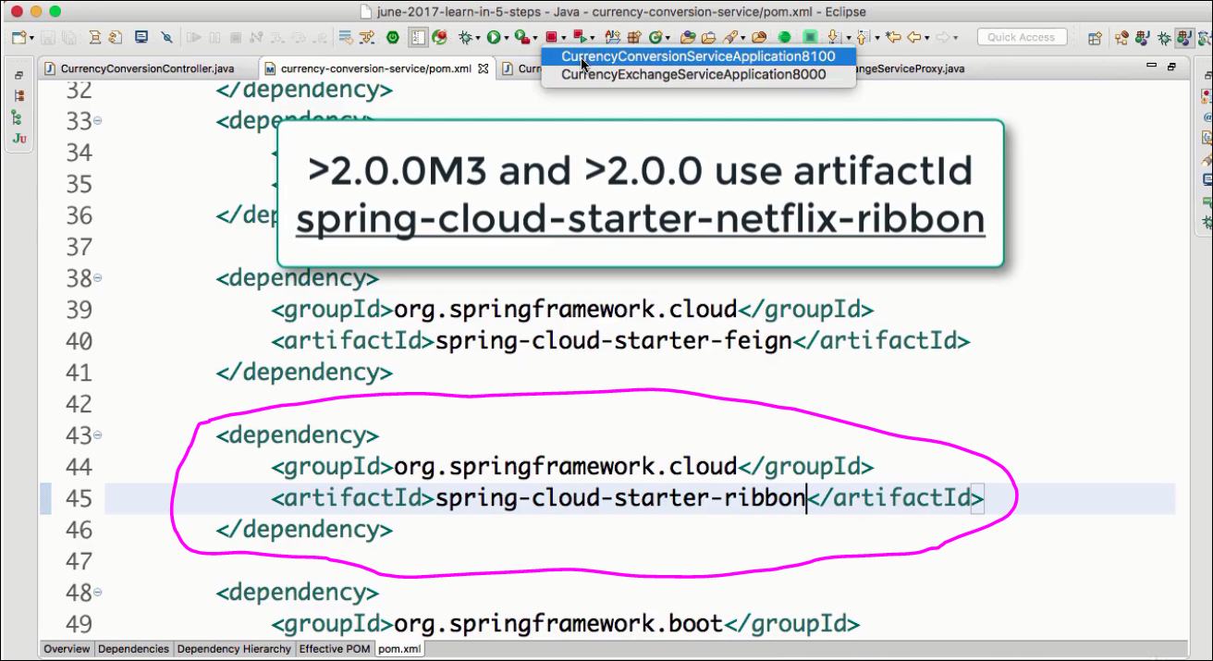**Step2: Enable Ribbon**

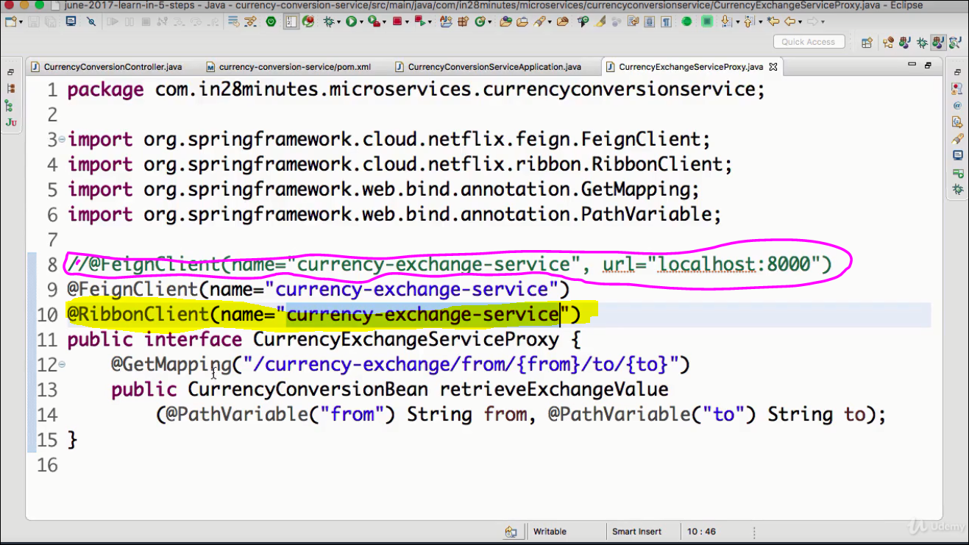

**Step3: Add URL in the application.properties**

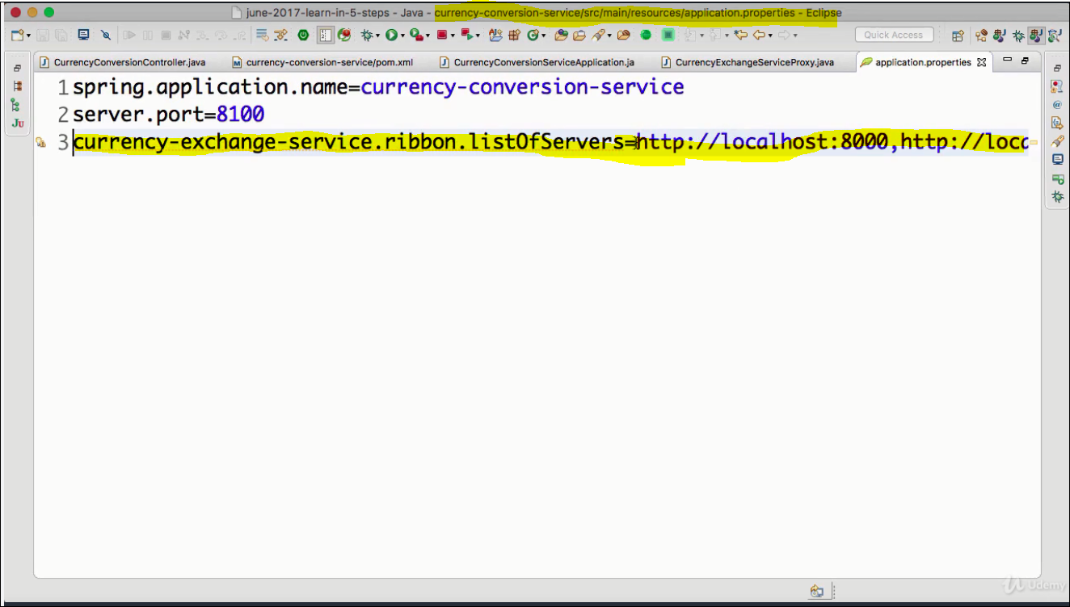

**Step4: Launch Currency Exchange Service on 8000 & 8001 port & test that they are available.**

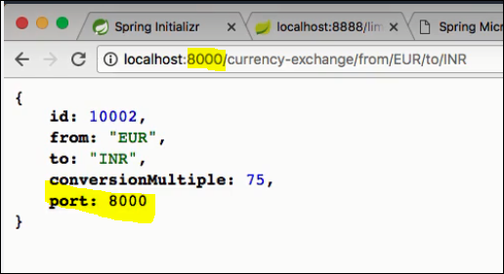

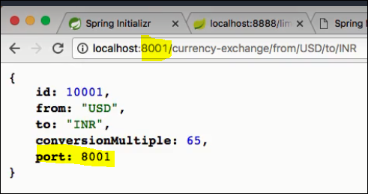

**Step5: Invoke currency concersion service & see the results:**

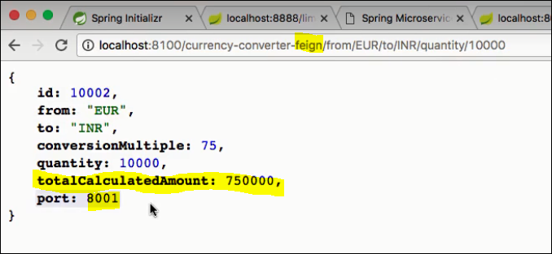

**Give a 2nd request & the request is delegated to CES instance on port 8000 .**

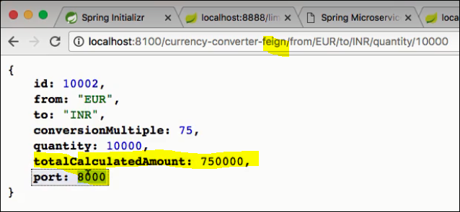

**Lecture 81: Understand the need of NAMING SERVER**

Q: What will happen when one of the instance of CES service is down?Will ribbon able to manage

Ans: No.CES property needs to be changed

Q: What will happen when one of the instance of CES service is added?Will ribbon able to manage

Ans: No.CES property needs to be changed

This is where NAMING SERVER ( EUREKA) comes into picture. When ever a service instance is added or removed , it should be registered or revoked from the NAMING SERVER. This is called SERVICE REGISTRATION

Similarly all the service communicating to another service needs to check with NAMING SERVER on the availability of the target service. This is called SERVICE DISCOVERY.

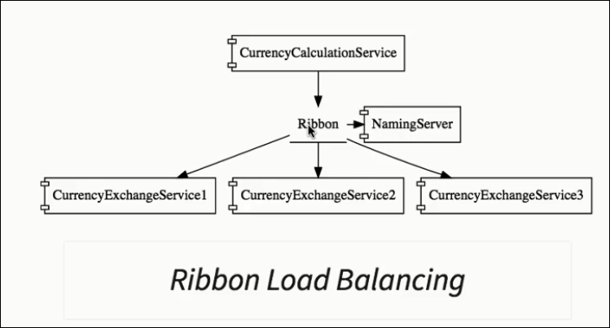

**Lecture 82: Setting up Naming Server**

* **Create Naming Server- Eureka**
* **Register Currency Exchange Service to Eureka**
* **Register Currency Conversion Service to Eureka**
* **Configure Ribbon to talk to Eureka.**

**Step1: Create Naming Server- Eureka**

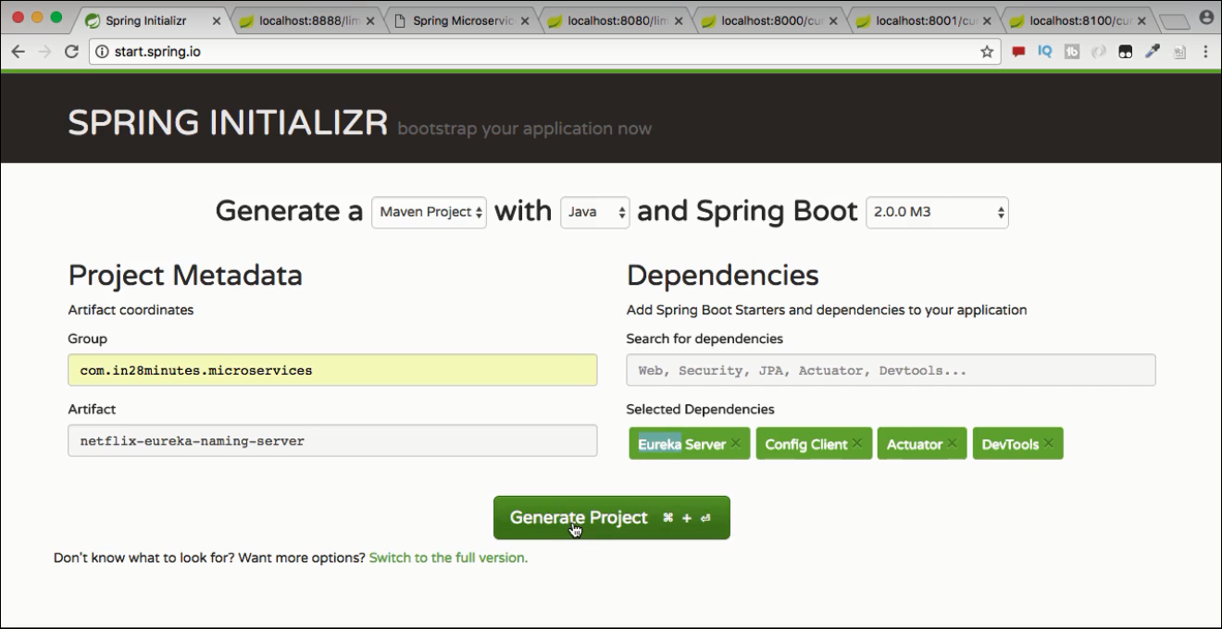

**Step2: Download and import it to workspace as maven project**

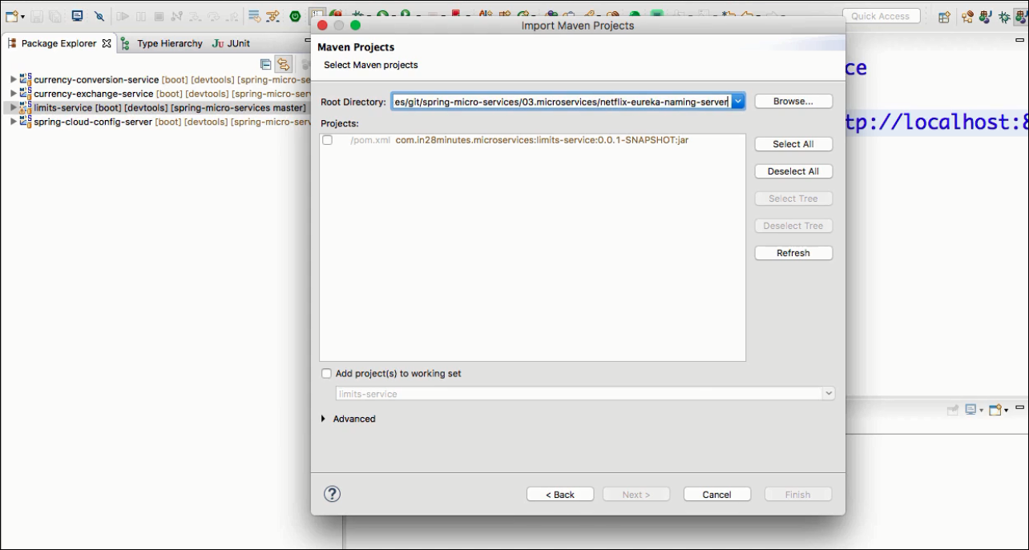

**Step3: Enable EurekaServer in NetflixEurekaNamingServerApplication**

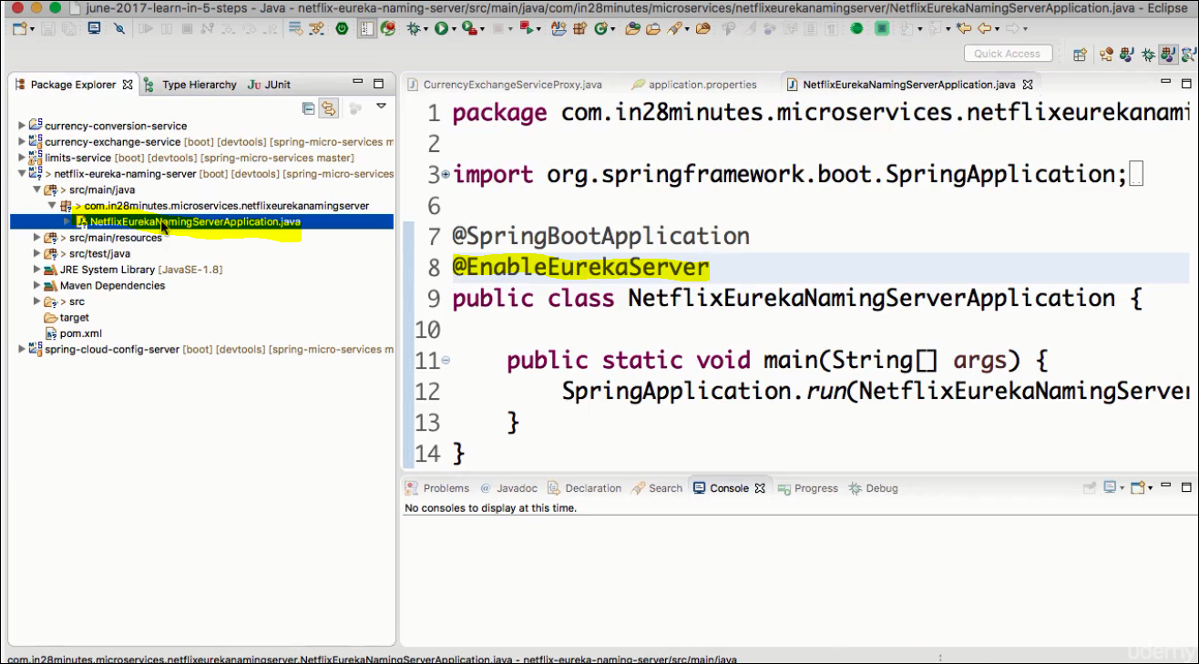

**Step4:**

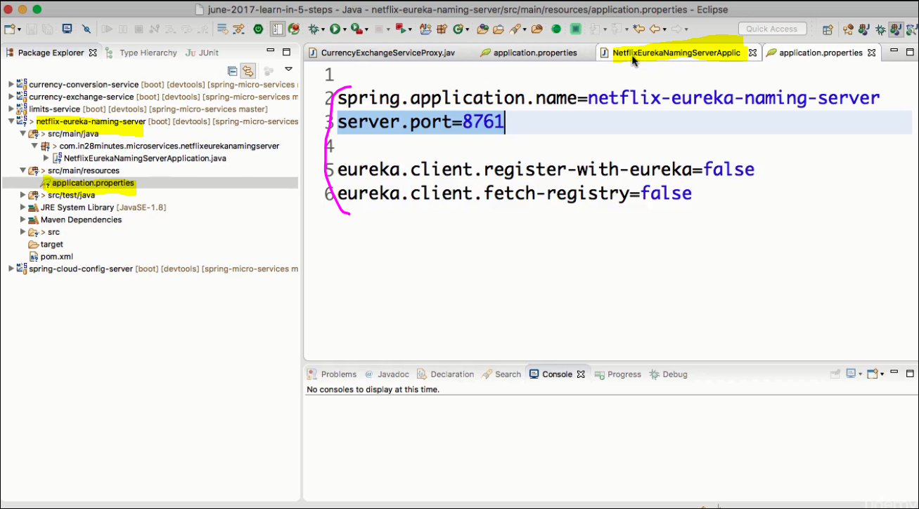

**Step5: Restart Eureka service & Test on browser.**

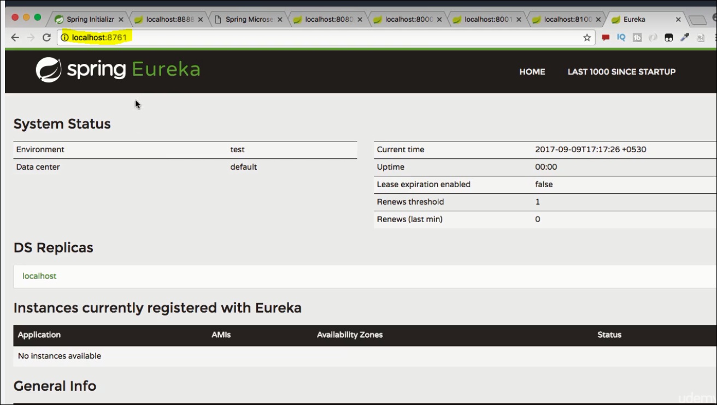

**Lecture 83: Connect Currency Conversion Microservice to Eureka**

**Step1: Add dependency in pom.xml of CCS service.**

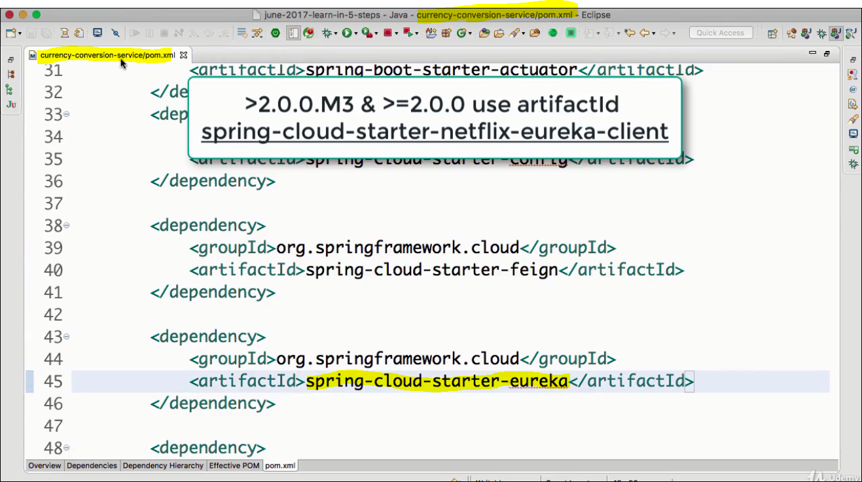

**Step2: Enable Discovery Client**

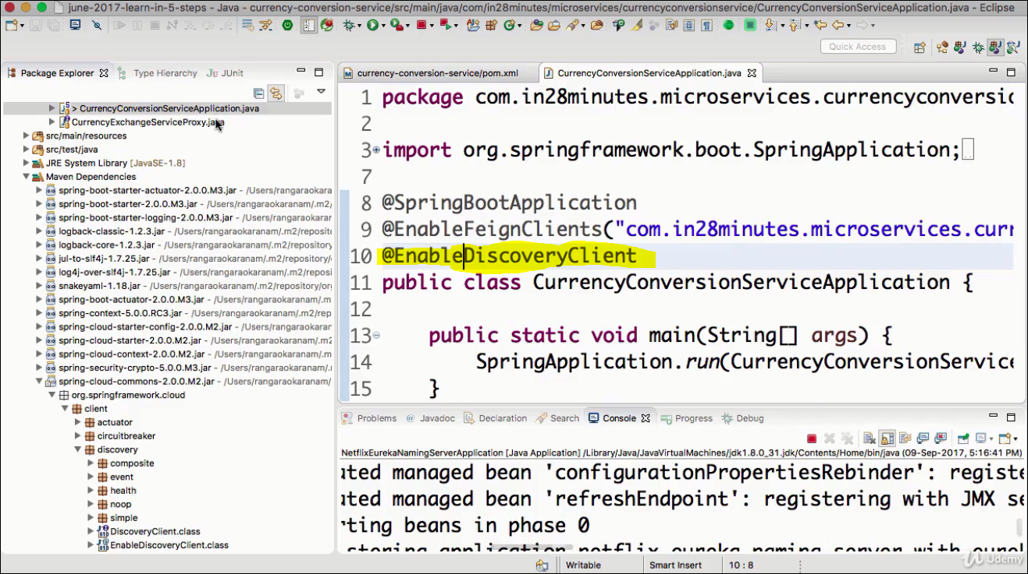

**Step3: Add Eureka Server URL to application.properties**

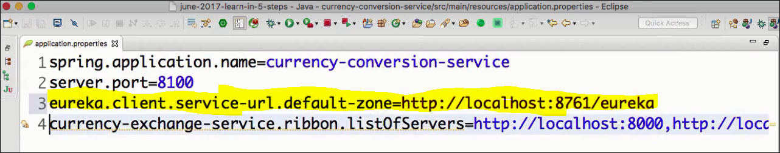

**Step4: Restart the CCS m/s and check if it registered in the Eureka service.**

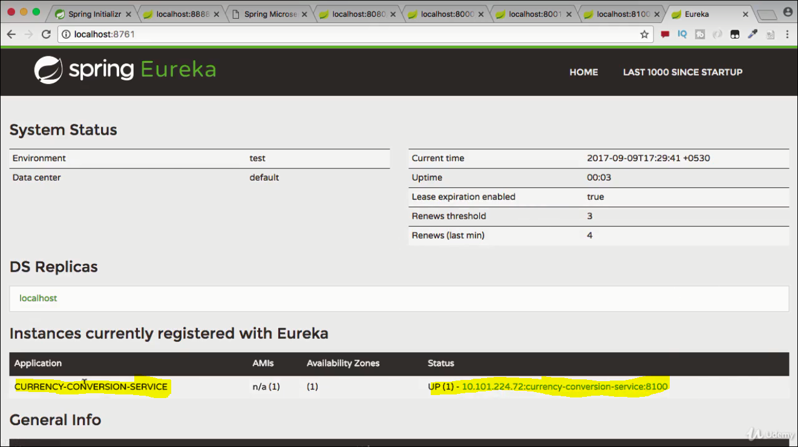

**Similarly launch another service instance of CCS and check here .**

**Lecture 84: Connect Exchange Microservice to Eureka**

**Step1: Add dependency in POM.xml**

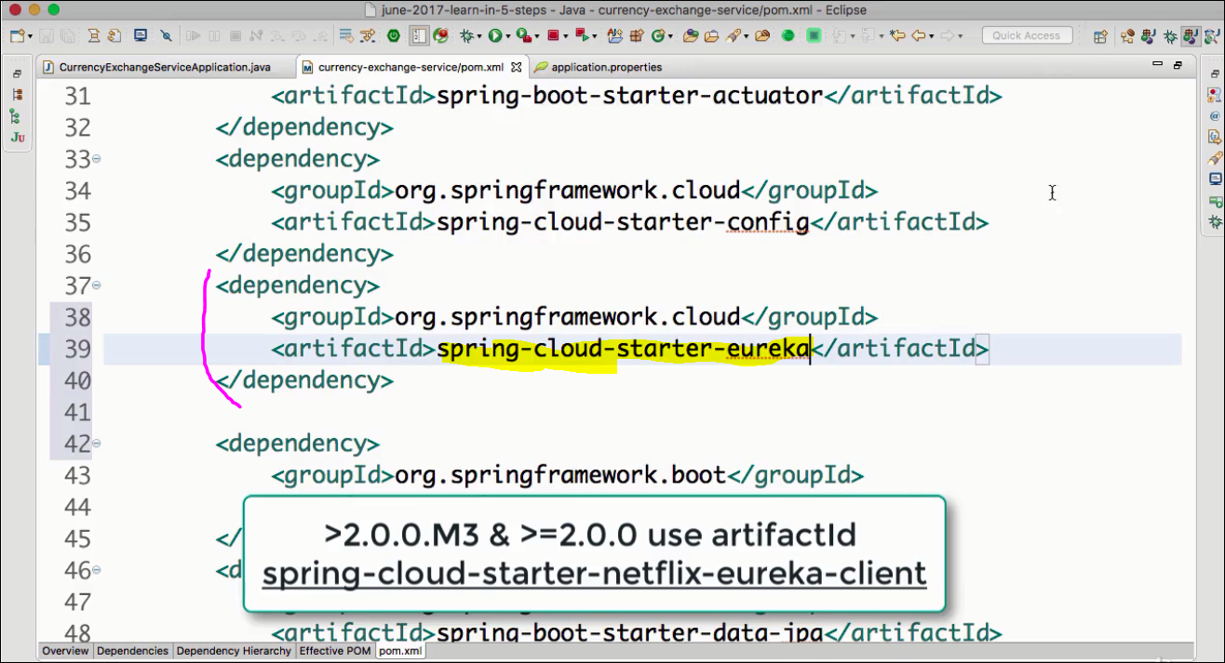

**Step2: Enable Discovery Client**

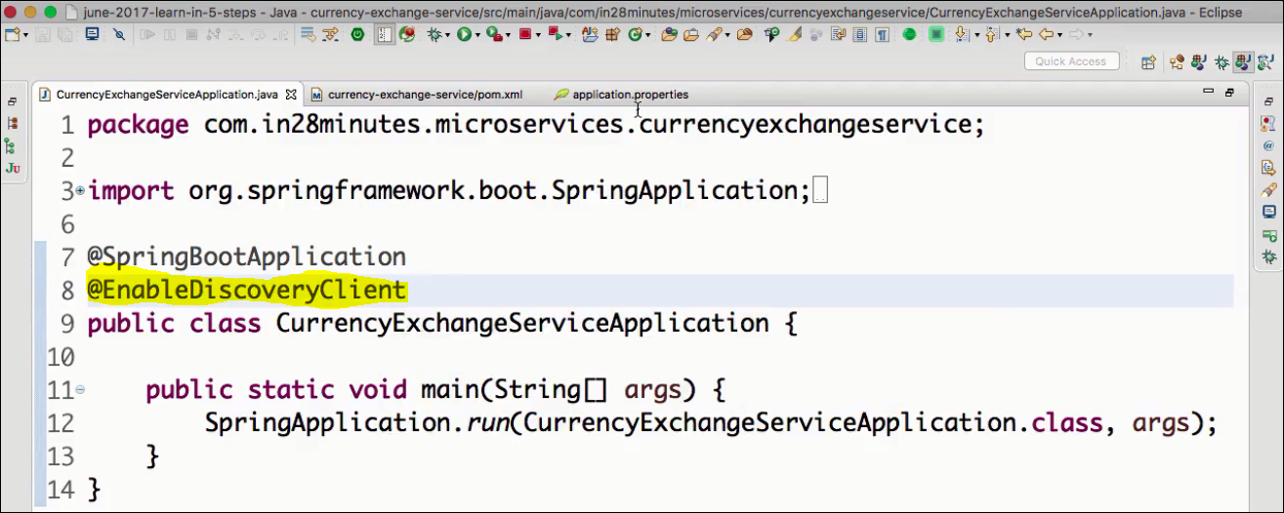

**Step3: Add Eureka Servive URL to application.properties**

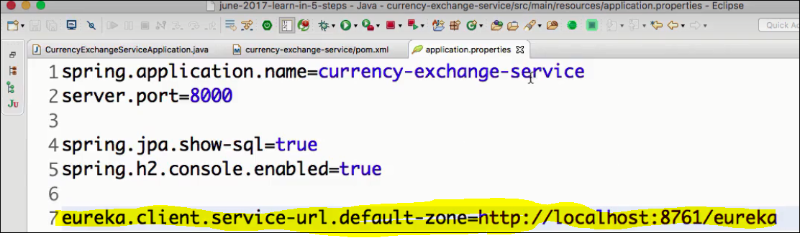

**Step4: Restart the CES m/s and check if it registered in the Eureka service.**

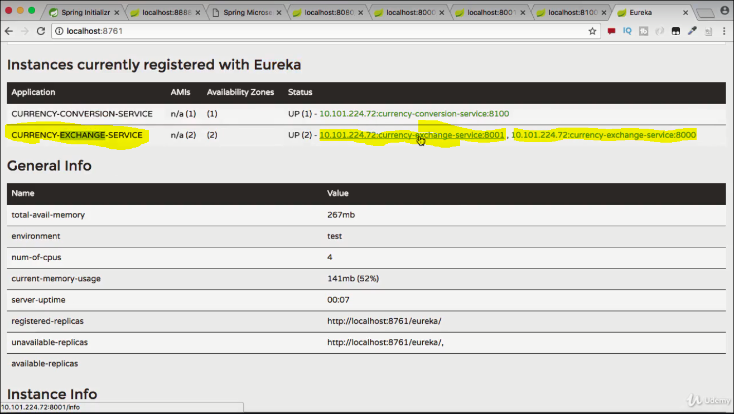

**Lecture 85: Distributing calls using Ribbon & Eureka**

**Step1: Simple: comment the below line**

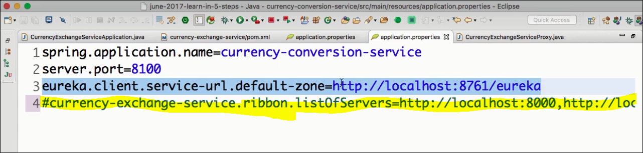

**Step2: Kill all the service running**

**Step3: Start up the application in below sequence :**

1. **Start the Eureka Naming Server on 8761**
2. **Start the CES m/s on 8000**
3. **Start the CSS m/s on 8100**

**Step4: Verify the same on Eureka console**

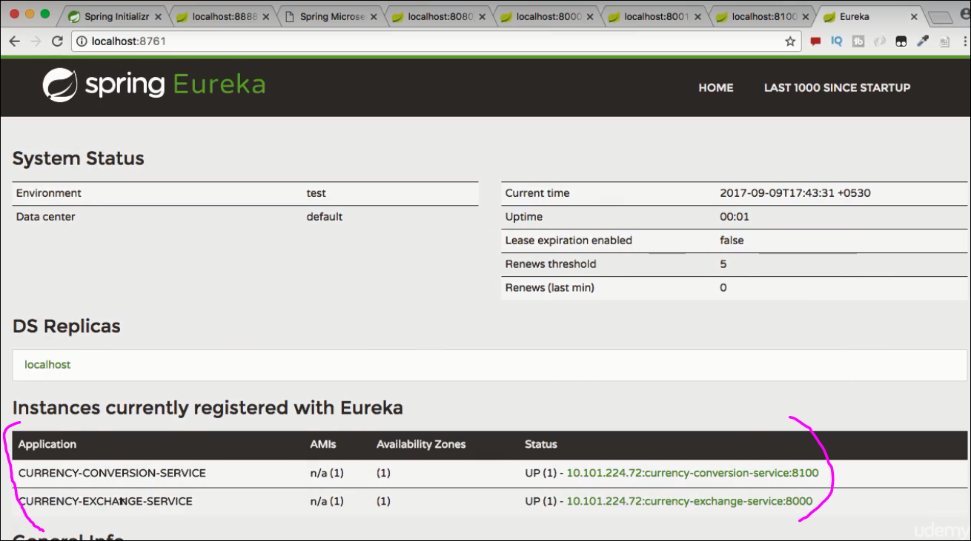

**ALLOW 1-2 min for the Eureka to come up fully.**

**Step5: Test the CES & CCS m/s .**

**CES------------->OK**

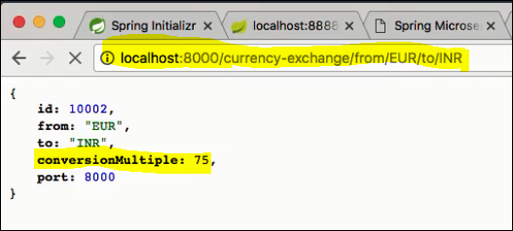

**CCS --------------------> OK**

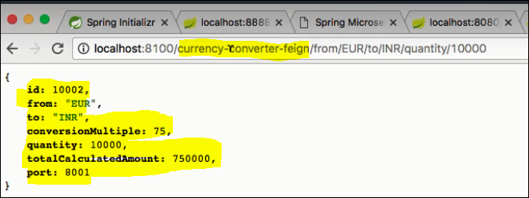

**Step5: Scalup test**

**Start Start the CES m/s on 8001**

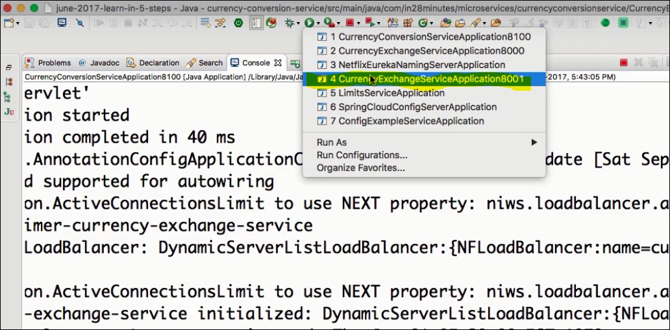

**Now if we start hitting CCS , it alternatively goes to CES on 8000 & 8001.**

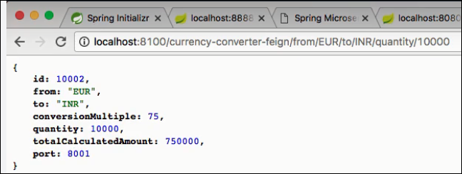

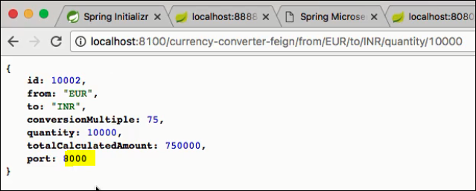

**Step6:/Scaledown test**

**Now kill instance of CES on 8000 & invoke CSS , it will got to CES on 8001 automatically.**